

HEE EoE Educator Bursary Approval Process [2018/19]


Applicant discusses their application with their Training Programme Director (TPD) and/or Director of Medical Education (DME) and obtains their support, prior to applying to HEE and a University (HEI). If you are TPD or DME please obtain Head of School or Deputy Dean approval.


If supported by TPD and/or DME, the applicant applies to a Higher Education Institute (HEI), ideally in the east of England by the end of this financial year


Applicant sends completed application form, along with their HEI application letter, to

educatorsfaculty.eoe@hee.nhs.uk, before the deadline of 23 January 2019.
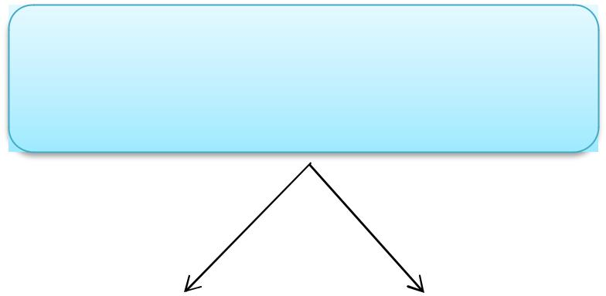

Panel of Educators at HEEoE reviews all applications

and ranks them according to pre-determined

criteria. This will be done by 25 January 2019

If approved If not approved


Faculty Team informs applicant of their

successful application on
25 January 2019


HEE EoE contacts University to organise bursary funding. The funding is paid directly to the University


Faculty Team informs applicant of their unsuccessful application on
25 January 2019



The decision of the panel will be final and, as there is no additional funding available, there will be no right to appeal. Feedback on unsuccessful applications can be requested.


